Mini laser distance sensor BLR-Z series User Manual
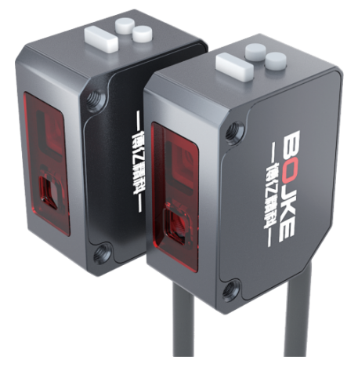
ΔWarning
。 The light source of this product adopts laser.It is prohibited for laser beams to directly or indirectly reflect from reflective objects into the eyes.If the laser beam enters the eyes, it may pose a risk of blindness.
。This product does not have an explosion-proof structure. Prohibited from use in flammable, explosive gas or explosive liquid environments.
。 Do not disassemble or modify this product, as it is not designed to automatically turn off laser emission when the body is opened. If the client disassembles or modifies this product without authorization, it may cause personal injury, fire, or electric shock hazards.
。 Using control, adjustment, or operation steps outside of the regulations here may result in hazardous radiation leakage.
Δ Attention
。It is very dangerous to perform wiring, connection/disconnection interface operations when the power is turned on. Please make sure to turn off the power before operation.
。Installation in the following locations may cause malfunctions
1、A place covered in dust or steam
2、The places that generate corrosive gases
3、The places that will directly receive scattered water or oil 4、The places subjected to severe vibrations or impacts
。 This product is not suitable for outdoor use.
。 Do not use this sensor in an unstable state shortly after the power is turned on (approximately 15 minutes warm-up time)
。If a switching power regulator must be used, please ground the grounding terminal. Do not connect to high-voltage cables or power lines. Operation failure will result in induction or damage faults, as each product has differences, so there may be subtle differences in the detection characteristics of the workpiece.
。 Do not use this product in water.
。 Please do not disassemble, repair or modify this product without authorization, otherwise it may cause electric shock, fire or injury to human body.
。 Wipe off dust on the transmitting or receiving components to maintain correct detection. Avoid direct impact of external objects on this product.
。 Operate within the rated range

This product cannot be used as a safety device to protect the human body

Dimensional Drawing

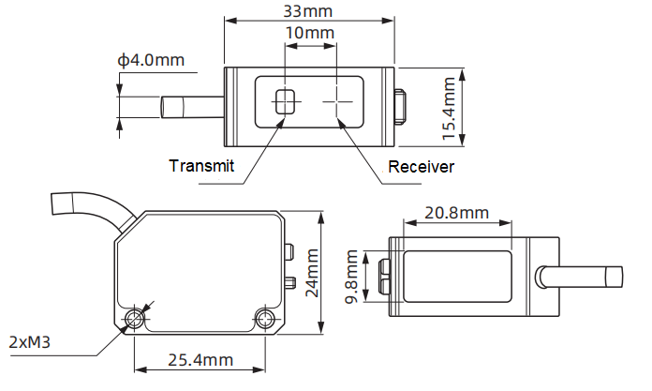

Circuit Diagram
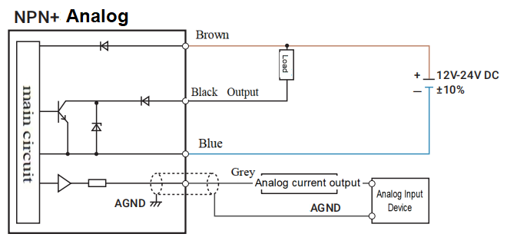
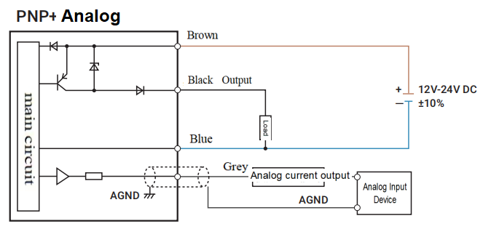

Panel Description

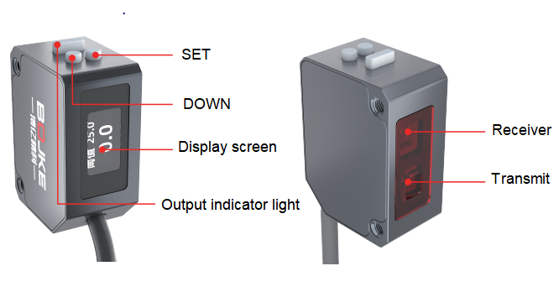

2
Product advantages

1、Distance measurement type
By utilizing the principle of triangulation, the distance of the target object can be accurately calculated and subtle changes can be perceived through the fluctuation of the peak position reflected by the laser on the CMOS.
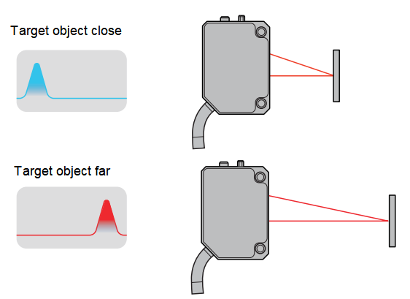
2、Automatic power control
Automatically adjust the luminous intensity and CMOS gain based on the reflectivity of the tested object, with an adjustment range of 2 million times, ensuring stable detection even for transparent objects.
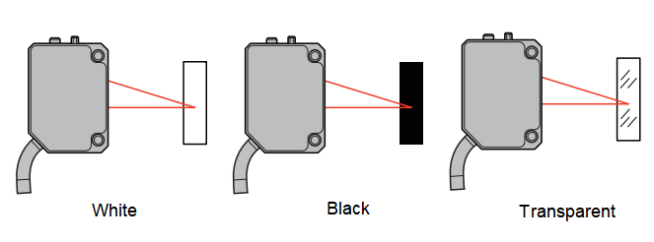

3、Multiple detection modes
The BLR-Z series CMOS laser sensor provides multiple detection modes to meet diverse detection needs, and different detection modes can be selected according to different usage scenarios
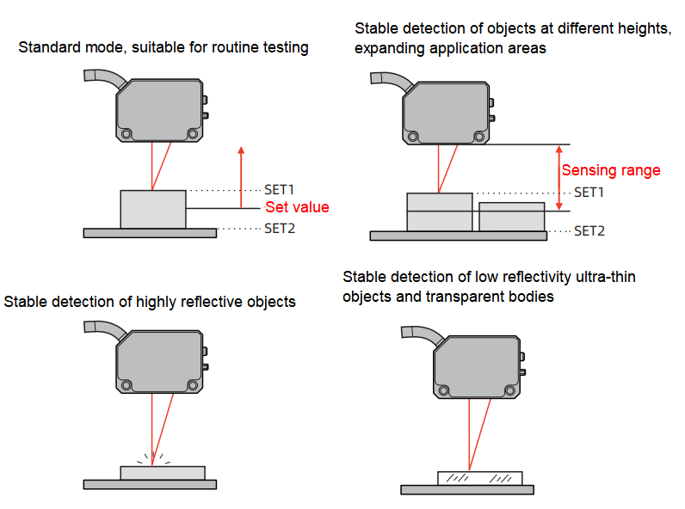

Specifications
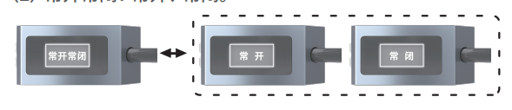
- Detection modes: standard detection, range detection, light quantity detection

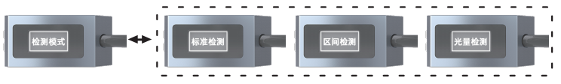
Model：NPN+Analog | BLR-Z300NA
Model：PNP+Analog | BLR-Z300PA
Detection range | 25mm-200mm
Tolerance in each range | 25-100mm:1mm，100-200mm:2mm
Display resolution | 0.1mm  - Hysteresis:99.5  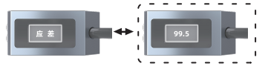  - Timer: no timer, On depay, Off delay, one time output, timer setting.  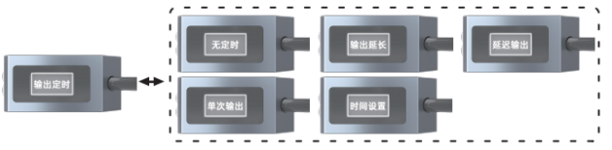  - Display modes: Reverse,Offset, Standard  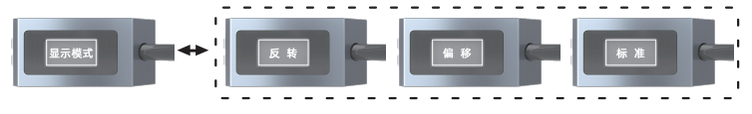
Linear Precision | ±0.2% F.S.
Repeat Accuracy | 25-100mm:0.5mm，100-200mm:1mm
Response time in each range | 400us、4ms、8ms
Light source | class Ⅱ laser, 655±10nm <1mW
Timer | No timer,On delay, Off delay, one-shot delay
Supply Voltage | 12V-24V DC±10% 脉动P-P10%
Consumption Current | 1≤50mA@24V
Indicator | Output indicator light:Yellow；Power indicator light:green;
Control output | NPN or PNP
Control output | Open drain collector transistor output
Control output | Max current：50mA
Control output | Applied voltage：<30V DC
Control output | Residual voltage：<1.5V
Control output | Leakage current：< 0.1mA
Output Operation | NO/NC switchable  - Hold: hold on, hold off  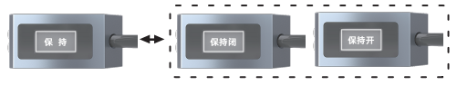  - Screen shutdown options: always on, timed shutdown.  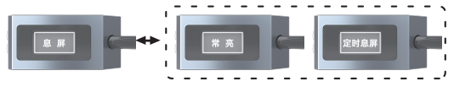  - Language: Simplified Chinese, English  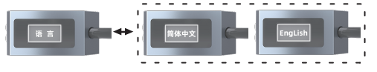
Short circuit protection | Automatic recovery type
Protection Circuit | polarity reversal protection/surge protection/short circuit protection
Analog current output | output range：4-20mA（alarm：0mA） Output Impedance： Max 300Ω
Protection degree | IP67
Ambient temperature: | -10℃~+45℃ (no condensation, no freezing)
Storage temperature | -20℃~+60℃
Operation humidity | 35%~85%RH
Ambient Illuminace | Illuminace Incandescent lamp ≤ 3000Lux;
Use elevation | ≤ 2000m
Cable cover | PVC
Material | aluminum alloy
Weight | about 85

- Reset: Press the "SET" button to confirm the reset → the display shows successful reset.

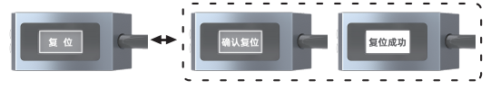
Menu Settings
Press and hold the "SET" button for 3 seconds on the distance display to enter the menu settings mode.
Short press the "SET" key to enter the menu, and short press the "DOWN" key to exit .
（1）Working mode: high precision, standard, high speed.
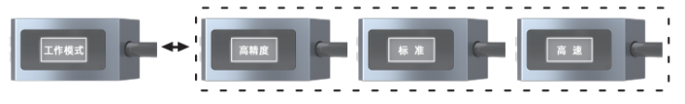

（2）NO/NC: NO,NC Product warranty
When ordering our products only reference sample, the following guarantees,disclaimers, conditions of fitness etc should apply when no special instructions are mentioned in the quotation sheet, contract, specification,etc.
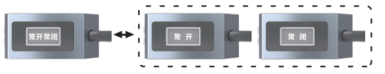

Before order please ensure you read and confirming following.
1、Quality Guarantee Period
Quality guarantee period is one year, calculated from the date when product delivered to buyer’s destination.
2、Range of Guarantee
We will repair the commodity free if the damage caused by our company.
It’s will not belong to the range of guarantee if caused by following reason:
1)Damage caused by use under conditions except the conditions, environment and use method described in the product manual of the company.
2)Faults not caused by our company.
3)Product damage caused by the personal modification and repair except the manufacturer.
4)Didn’t according to usage method of our company description.
5)After the goods are delivered, the problem caused by unpredictable scientific level.
6)Others failures caused by natural disasters, disasters and other factors
At the same time, the above guarantee only refers to the company's products, and the other damage caused by the company's product failure is excluded from the guarantee range.
3、Limits of Liability
1) The Company should not be liable for any special loss, indirect loss, and other related losses (eg:equipment damage, loss of opportunity,loss of profit) caused by incorrect use of company's products.
2)When using programmable equipment, our company will not assume any responsibility for the programming carried out by non-company personnel and the consequences arising therefrom
4、Suitable for use and conditions
1)The products of our company are designed and manufactured for general products of general industry. So, the products of our company should not be used for the following applications and not suitable for their use.If it is necessary to be used in the following occasions, please discuss with the sales of our company to confirm the product specification, and select the product which suitable. At the same time,we should consider various safety countermeasures, such as the safety circuit that can minimize the danger even if there is a failure.
Facilities that have a serious impact on life and property, such as atomic energy control equipment, incineration equipment, railway,aviation and vehicle equipment, medical equipment, entertainment equipment, safety devices and equipment that must comply with the special provisions of administrative agencies and individual industries.
Public utilities such as gas, water, power supply systems, 24-hour continuous operation systems and other equipment requiring high reliability.
Systems, equipment and devices that may endanger personal and
Outdoor use under similar or similar conditions.
2)When the user uses the company's products in occasions closely related to personal and property safety, the overall risk of the system related to personal and property safety, the overall risk of the system should be adopted. At the same time, according to the applicable purpose of the company's products in the system, supporting power distribution and settings should be supply.
3)Please be sure to follow the precautions and prohibitions to avoid incorrect use and damage caused by a third party.
5、Range of services
The product price does not include the dispatch fee of technicians and other service fees. If you have any demand in this, you can contact us to negotiate.

4 5 6

